**Domain Theory**

1. 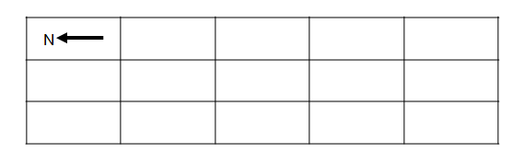Complete the following diagram showing how the domains might appear for an   
   *un-magnetized* object.
2. Complete the following diagram showing how the domains might appear for an   
   *magnetized* object.

1. Explain if all metals can be magnetized. (Hint: Research *ferro-magnetic* materials.)
2. Explain what would happen if you break a bar magnet in half.

1. Explain if magnetism in a material is permanent or if and how it can be changed.

**Law of Magnetic Poles**

1. Use the Law of Magnetic Poles to answer the following:
   1. South and South ( Attract / Repel / Neutral )
   2. South and North ( Attract / Repel / Neutral )
   3. North and South ( Attract / Repel / Neutral )
   4. North and North ( Attract / Repel / Neutral )

1. Explain if a magnet will attract *any* un-magnetized metallic object or just *certain types* of un-magnetized metallic objects.

**Magnetic Fields**

1. Draw the magnetic field around the following bar magnet. Make sure to show the direction and density (intensity) of the magnetic field lines.



1. Draw the magnetic field lines showing the attraction between the following magnetic poles.



1. Draw the magnetic field lines showing the repulsion between the following pairs of magnetic poles.



1. Draw the magnetic field around the poles of the following horseshoe magnet. Make sure to show the direction and density (intensity) of the magnetic field lines.

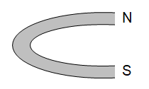

**Oersted’s Discovery**

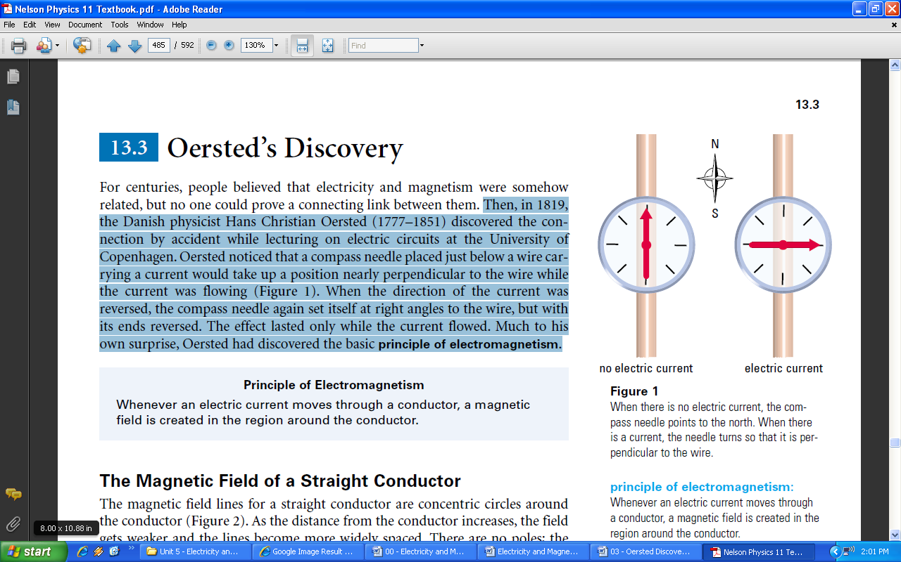

In 1819, the Danish physicist Hans Christian Oersted (1777–1851) discovered the connection, between electricity and magnetism, by accident while lecturing on electric circuits at the University of Copenhagen. Oersted noticed that a compass needle placed just below a wire carrying a current would take up a position nearly perpendicular to the wire while the current was flowing. When the direction of the current was reversed, the compass needle again set itself at right angles to the wire, but with its ends reversed. The effect lasted only while the current flowed. Much to his own surprise, Oersted had discovered the basic **principle of electromagnetism**.

**Principle of Electromagnetism**

Whenever an electric current moves through a conductor, a magnetic field is created in the region around the conductor.

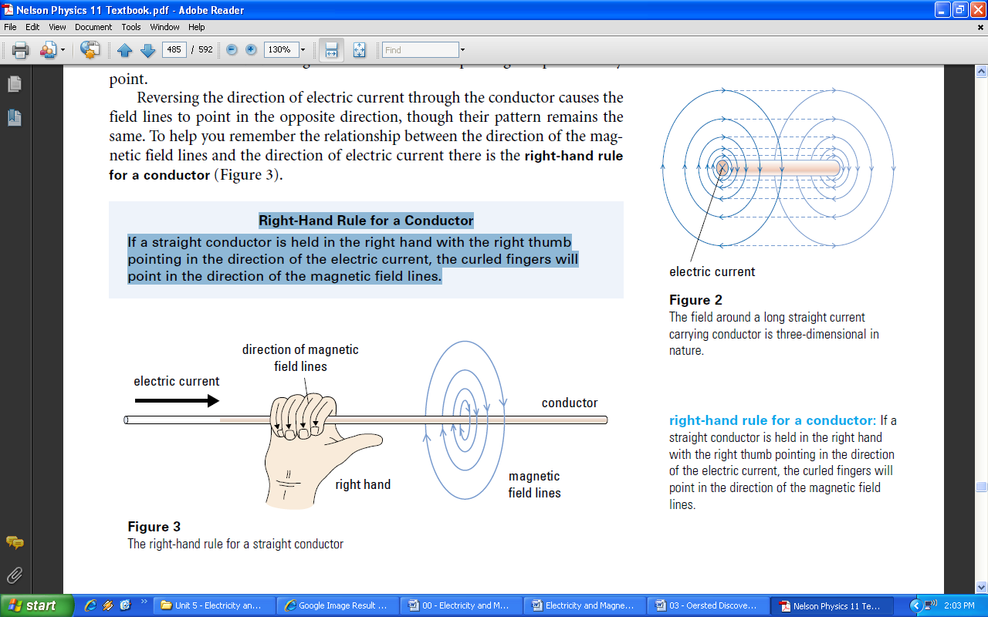**The Magnetic Field of a Straight Conductor**

The magnetic field lines for a straight conductor are concentric circles around the conductor (**Figure 2**). As the distance from the conductor increases, the field gets weaker and the lines become more widely spaced. There are no poles; the field lines are continuous and give the direction of the plotting compass at every point.

Reversing the direction of electric current through the conductor causes the field lines to point in the opposite direction, though their pattern remains the same. To help you remember the relationship between the direction of the magnetic field lines and the direction of electric current there is the **right-hand rule for a conductor.**



**Right-Hand Rule for a Conductor**

If a straight conductor is held in the right hand with the right thumb pointing in the direction of the electric current, the curled fingers will point in the direction of the magnetic field lines.

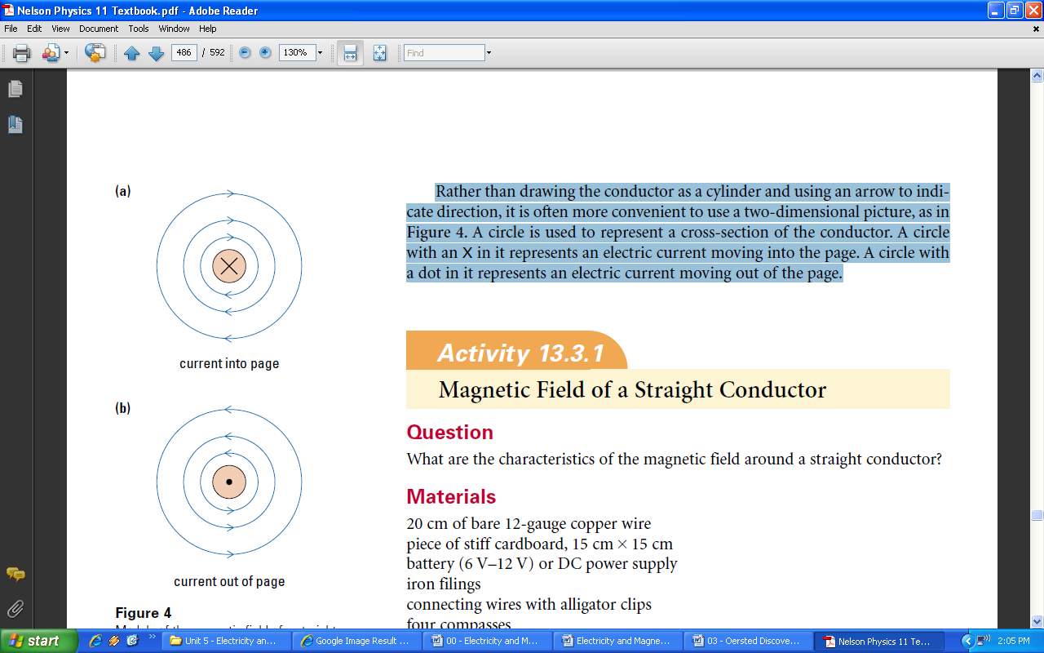

Rather than drawing the conductor as a cylinder and using an arrow to indicate direction, it is often more convenient to use a two-dimensional picture, as in **Figure 4**. A circle is used to represent a cross-section of the conductor. A circle with an X in it represents an electric current moving into the page. A circle with a dot in it represents an electric current moving out of the page.

**Oersted’s Principle**

1. 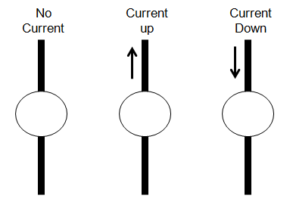Draw the direction of the compass showing Oersted's Principle in each of the following conditions
2. Show the direction of the magnetic field around the conductor in each of the following conditions. Also state if the current is into or out of the page.

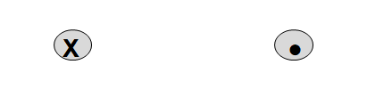

**Right Hand Rule #1**

1. Summarize the Right Hand Rule for Conductors as follows:
   1. Your Thumb points in the direction of:
   2. Your Fingers curl in the direction of:
   3. The direction of the field depends on the:
   4. The shape of the field is:
2. Draw a diagram showing how to use the right hand rule.
3. Use the Right Hand Rule to determine the direction of current for each of the following wires.

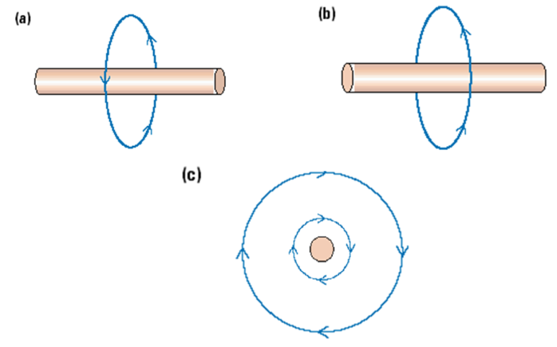

1. Use the Right Hand Rule to predict if the following parallel wires will attract or repel.

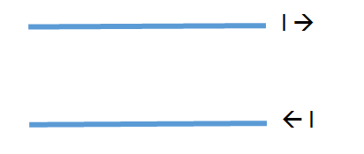

1. Use the Right Hand Rule to predict if the following parallel wires will attract or repel.

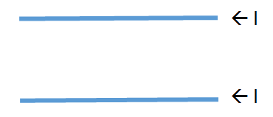

**Questions**

